PP BP Check Nurse Visit Documentation
This document outlines a standardized workflow for nurses performing postpartum blood pressure (BP) assessment visits. The workflow is designed to ensure consistent documentation, efficient charting, and the delivery of safe, high-quality patient care during all postpartum BP visits.

Navigating to the Nurse Visit Schedule

Nurse Visits are found on the multi-provider schedule.
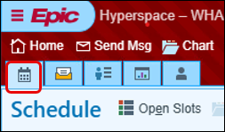
To access the Nurse Resource template:
- Click the expanding arrow next to the department.
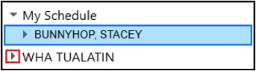
- Find the Nurse resource template.
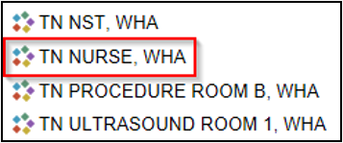

Documenting a Nurse Visit

- Single click the patient’s appointment to highlight it and review the Preview Pane reports.
- Double click the patient’s appointment to open the visit encounter.

Interpreter Documentation Activity:

- Click the Needs Interpreter banner to open the Interpreter Documentation activity.

An Interpreter window opens.

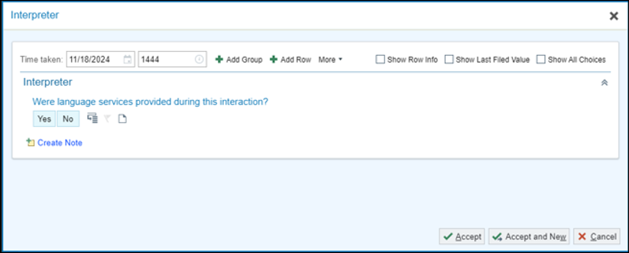

For Pamala’s appointment, document that you did use a telephonic interpreter from Linguava named Carrie Smith who is not OHA Certified.

- Were language services provided during this interaction?: Yes.
- Interpreter/Bilingual Staff/Visit provider: Professional Interpreter
- Interpreter/Bilingual Staff/Visit Provider Full Name: Carrie Smith and ID#
- Interpreter Mode: By Phone
- Interpreter Service/Agency: Linguava
- Is the interpreter certified or qualified through the Oregon Health Authority? Not Certified /Qualified by OHA.
- Click Accept once documentation is complete.
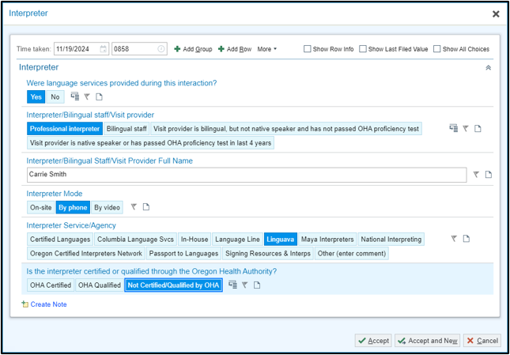

Rooming Activity: 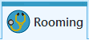
This activity is where you document the “intake” information for the patient.

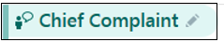
- In the search box 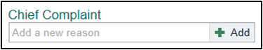,Type; hypertension.
- Press Enter.
- Comments: Postpartum
- Click Close.


Document the patient vitals you’ve obtained.
- BP: 110/74, include Site, Position, and Cuff size
- Heart Rate: 66
- Temp: 98.2
- Temp Src: Oral
- Weight: 123 lb – you must use units (lb or kg) when you document the weight.
- Height: 63in - you must use f for feet or i for inches.
- Add Comment to piece of paper icon: Previous recorded height
- Respiration: 12
- SpO2%: 99
- Confirm Tobacco history and Mark as Reviewed.
- Complete OBGYN Status: Breastfeeding, then Mark as Reviewed.

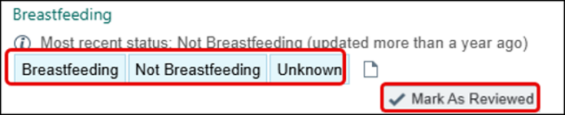

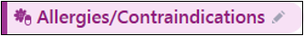

Verify the patient’s allergies. Add any new allergies the patient reports using the Add a new agent field.
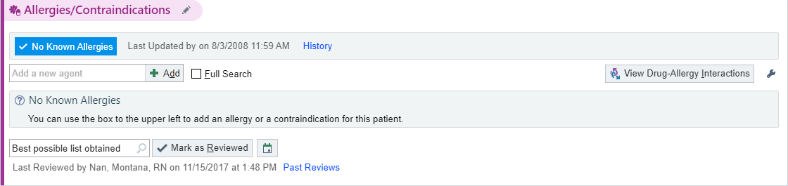
- Click Mark as Reviewed once completed.

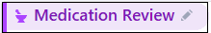

You’ll verify pharmacy information and review the patient's current medication list. Each medication should be marked as "Taking," "Not Taking," or "Taking Differently”.

- Click the Medication Review activity header to open it.
- Verify the patient’s pharmacy.
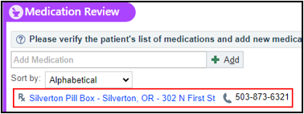
- Mark her medications as Taking, Not Taking, Taking Differently, or Unknown.
- Update Med List Status: Best possible list obtained.
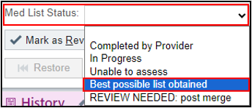
- Click Mark as Reviewed, then Close the activity.
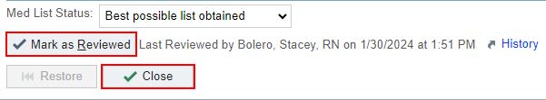

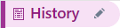

It may be necessary to review and update the patients’ OB, Past Medical or Surgical history. Since the patient has recently delivered; this information may not yet be recorded.

OB History
- Open the History activity using the pencil icon.
- Review the information in the Obstetric History section.
- Click the pregnancy to open the details.
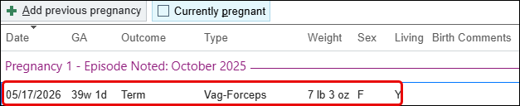
- Click the orange banner ‘Reconcile Outside Information’ to import data from external facilities, such as Providence when appropriate.
- Scroll to Additional Outcome Info at the bottom.
- Under Postpartum course, select preeclampsia if applicable.
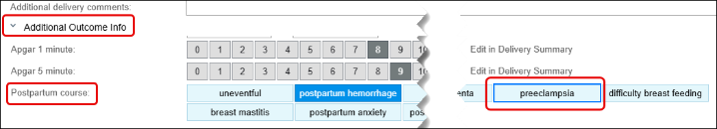

Medical History

- Scroll down to the Medical History section.
- To minimize the Quick entry section, click the Chevrons on the right side of the activity.
- If patient has a new medical diagnosis related to their OB admission, update Past Medical History.

Surgical History

- Scroll down to Surgical History.
- Click the Chevrons in this Quick entry section as well, to minimize it to be able to see the patient’s previous surgeries.
- If obstetrical surgery during hospital admission, add to her Surgical History.
- Scroll to the bottom and click Mark as Reviewed.

This Visit Activity: 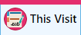

- Go to Visit Diagnosis activity.
- In the Search field, type: Postpartum Hypertension.
- Select the first option on the list, then click Accept.
- Click the green plus sign to push this to the Problems List.
- Scroll to the Problem List activity.
- Single-click on the problem you just added.
Now you need to link it to the Pregnancy Episode

- Click the Details hyperlink.
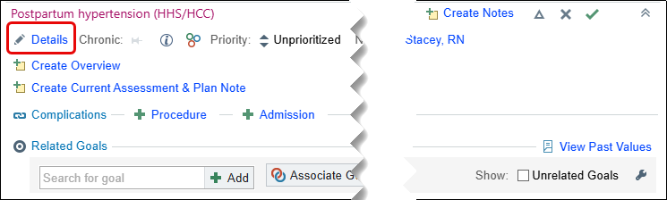
- Click the box next to Pregnancy, then Accept.
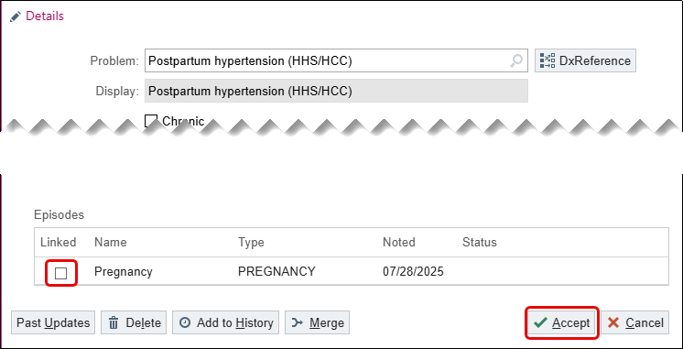
Now you’re ready to document in the Note.

Progress Note Activity: 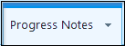

The note is mostly complete as it is constructed incrementally during the patient’s appointment. There are several features that streamline documentation in the PP BP Check Smartphrase.

- Go to your progress note in the sidebar.
- In the Insert SmartText box search for WHA BP CHECK and press enter.
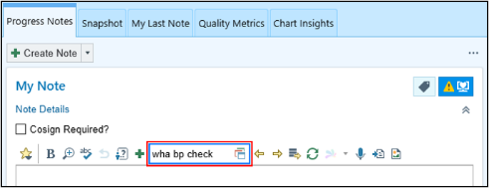
- Select WHA ADVICE OB BP CHECK VISIT and click Accept to pull in the note template.
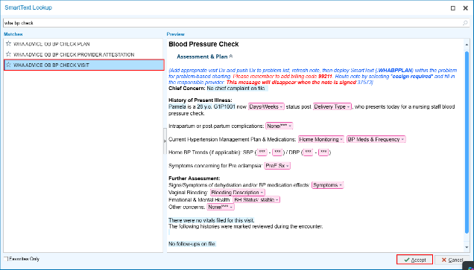

Notice the template pulls in discreet data, which is highlighted in blue.
When information is entered into the chart, these data links can continue to pull in information as they are “refreshable”. This means when you click refresh after new information is entered into the chart, that new information will pull into the Note.

- Press F2 or click to work through the variables and wild cards, as if the patient were present, applying your clinical judgment.
- Return to the top of your note.
- Click once beneath the Postpartum Hypertension problem.
- In the SmartText field type: WHA BP PLAN and press Enter on your keyboard.
- Select the appropriate Assessment from the list.
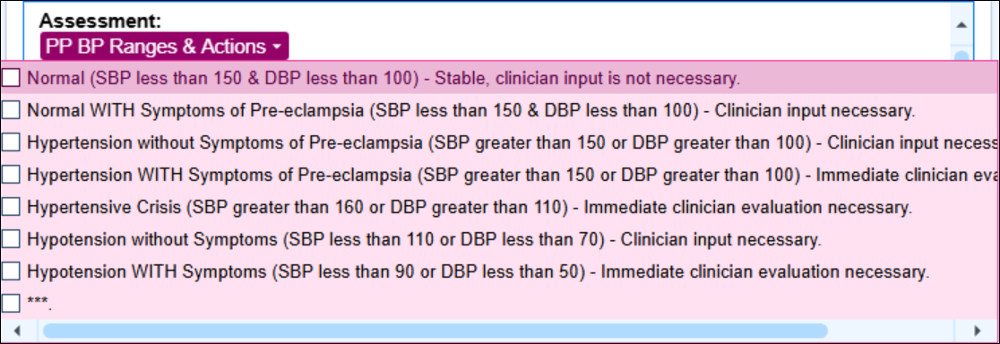
- Select the appropriate Plan from the list.
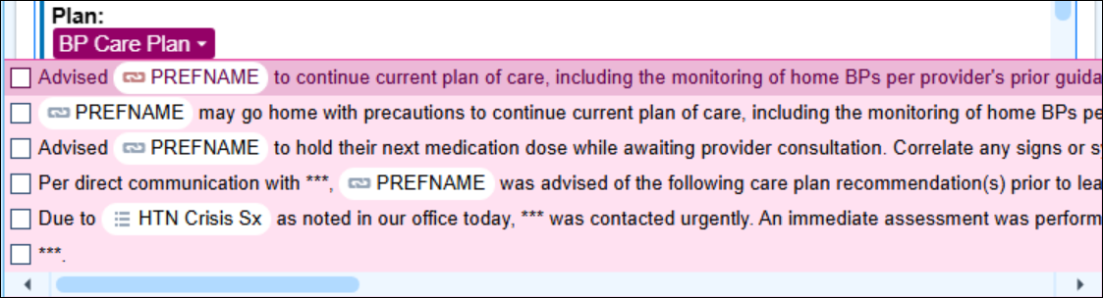
- Click the box next to Cosign Required and add the patient’s responsible provider.
  - When the visit is signed, it automatically sends a cosign InBasket message to the responsible provider that you listed.
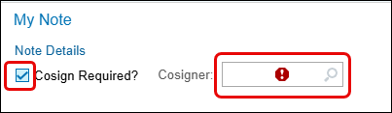
- Once all the variables have been satisfied, click Accept at the bottom of the Note.

This Visit Activity:

It is time to Wrap Up this visit.

In the right-hand column of This Visit the Patient Instructions, Follow Up, AVS information, Communications, and Charge Capture can be found.

You can use the system to search for visit-related materials that are available. Search for the template for educational materials.

- In the SmartText field; type LEAP WHA PI OB HOME BP MONITIORING and press enter to populate the information.
  - Note: Spanish version available.

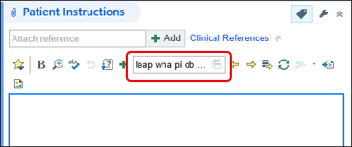
Document the patient’s appropriate follow up according to her BP check results and any potential provider recommendations.
- Go to Follow-up.
- Return on: [select the date of her next appointment]
- For: [insert the appointment type: 3-week pp, bp check, etc.]
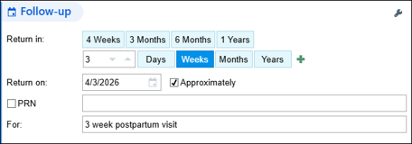

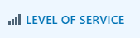

- Go to Level of Service in the visit task bar at the bottom right of the screen.
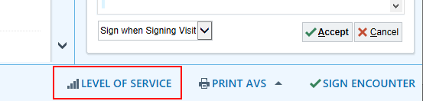
- Click the RN Visit button to select that level of service.
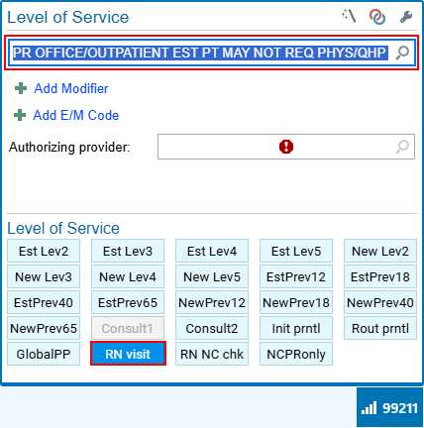

- Complete the hard stop.
- Add your Authorizing provider.
  - This will most often be the office call Provider for that day.

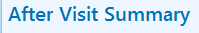
Another part of Meaningful Use measures is to give the patient a copy of today’s visit.

- Click the Preview button to review the AVS prior to giving it to the patient.
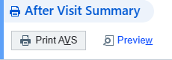
- Click the Sign Encounter 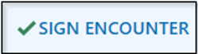 button to close the encounter once all documentation is complete
The Schedule will show her appointment as ‘Signed’ 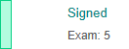

Adding a Provider to the Appointment

When a provider consultation is required for abnormal blood pressure readings, the provider should be added to the existing appointment rather than creating a new appointment, to avoid generating a duplicate encounter.

- Go to the patient’s Appt Desk.
- Right click the Nurse Visit appointment.
- Click Change Appointment.
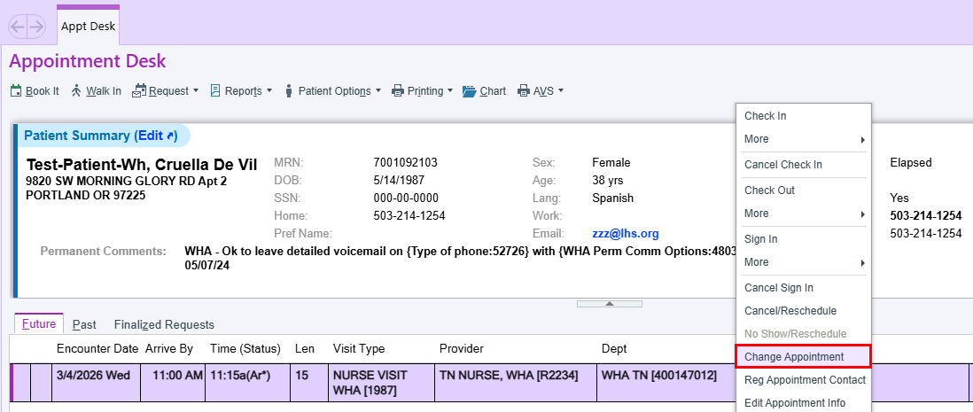
- Click Add Provider.
- Enter the name of the provider that needs to be added to the appointment.
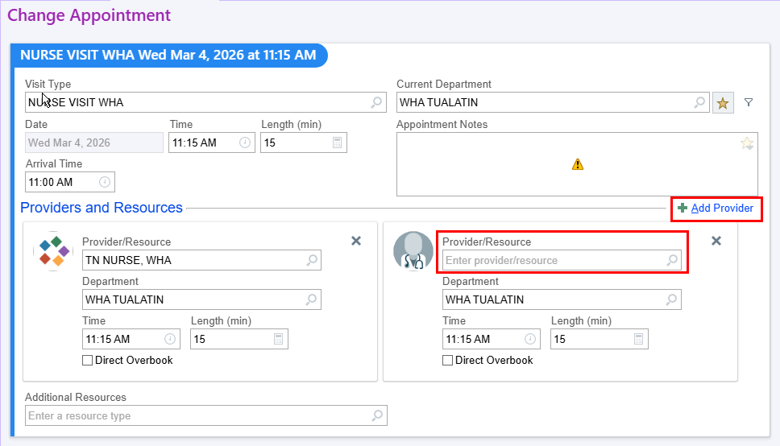
- Enter the Reason for Change.
- Click Change.
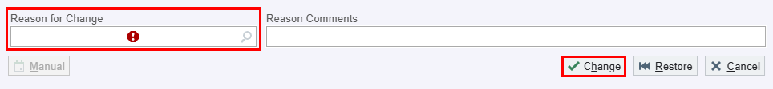

The appointment now displays two providers, allowing each provider to complete any necessary documentation without creating duplicate appointments in the patient's chart.
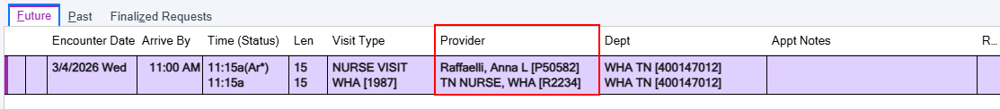
You will need to make sure you go back and open the visit to document this piece before you release the patient to see the provider.

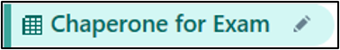
- Click the pencil or the New Reading button.
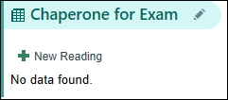
- Verify with the patient whether she would like to have a chaperone for her visit and click the corresponding button.
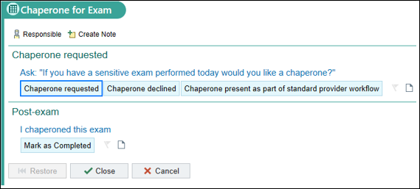
- Click the Chaperone Declined button.
- Skip the Post-exam section and click Close.

Pre-Charting a Nurse Visit
Pre-charting enables you to document in advance, allowing for more focused time with the patient during the appointment. This feature is available when the patient's appointment status is listed as Scheduled, with access to a limited set of sections.
- Double click on the patient’s chart.

Please note the Pre-Charting information box. Since the patient has not yet arrived, do not click "Start the Visit.”
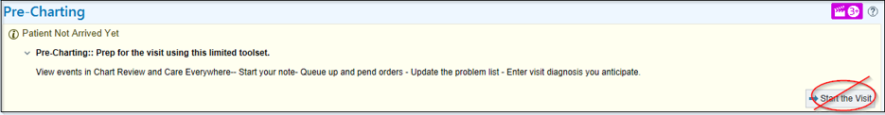

Progress Notes Activity:

- In the SmartText Field add LEAP WHA OB BP CHECK VISIT.

Only historical information can be added in the Progress Note when you are in a pre-charting status.

- Use the smartphrase variables to document any applicable historical information for the patient.

Pre-Charting Activity: 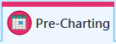
Here you can add the Visit Diagnosis, Patient Instructions and review the Problem List. The Problem Lists are managed by the providers only.

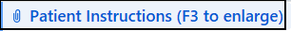

- In the SmartText field, type: LEAP WHA PI OB HOME BP MONITORING

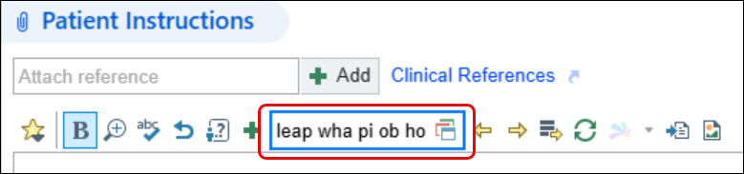

- To select the smartphrase either press enter or double click from the list.

You have finished Pre-Charting and can now exit chart.

